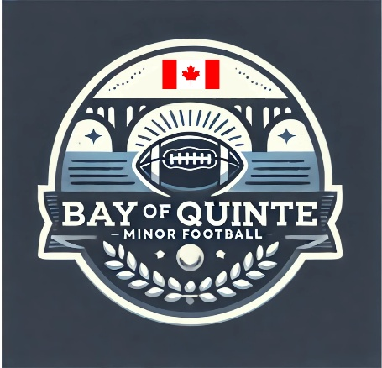

Section: Code of Conduct | Approval Date: February 12, 2026
Subsection: Players | Review Date: February 6, 2026
Policy Title: Player of Conduct | Creation Date: July 17, 2025
Pertains To: All Players on a BQMF Team

All players on a Bay of Quinte Minor Football (BQMF) team are expected to:

- Play for the fun of it, not just to please parents or coaches.
- Respect your coaches, teammates, equipment, opponents, and officials.
- Play by the rules at all times.
- Never argue with officials’ decisions. If clarification is needed, allow your team captain or coach to ask questions respectfully.
- Control your temper—no mouthing off, illegal hits, or throwing equipment.
- Work equally hard for yourself and your team—your team’s performance will benefit, and so will you.
- Be a good sport. Cheer for all good plays, whether made by your team or your opponents.
- Treat all players as you would like to be treated. Do not interfere with, bully, or take unfair advantage of any player.
- Remember that the goals of the league are to have fun, improve your skills, and learn the game of football.
- Cooperate with your coaches, teammates, and opponents—without them, there is no game.

