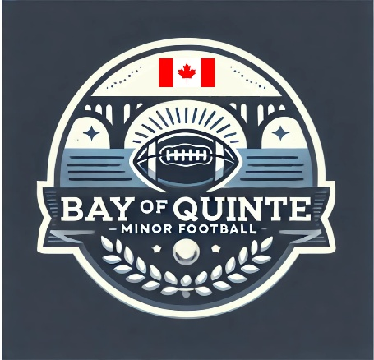

Section: Code of Conduct | Approval Date: February 12, 2026
Subsection: Integrity Commission | Review Date: February 6, 2026
Policy Title: Integrity Commission | Creation Date: July 17, 2025
Pertains To: The role and representatives of the integrity commission

Integrity Commission Policy
Bay of Quinte Minor Football (BQMF)

All individuals involved with Bay of Quinte Minor Football (BQMF) are expected to conduct themselves with the highest degree of courtesy, integrity, and respect. It is BQMF policy that all players, coaches, parents/guardians, league representatives, and volunteers involved in any BQMF game, event, or practice maintain a sportsmanlike and educational atmosphere before, during, and after all BQMF-sanctioned activities.

When a coach, parent/guardian, player, spectator, or league representative appears to violate league expectations of conduct, the applicable Codes of Conduct outline the standard process for addressing the situation.

While most conduct issues are expected to be resolved through existing conduct policies, repeat offences or serious violations may require review by an independent body. For this reason, Bay of Quinte Minor Football maintains an Integrity Commission to review incidents and conduct matters that:
- Warrant an independent investigation
- Require guidance for the League Commissioner in determining appropriate action
- Are formally disputed by a parent/guardian, coach, spectator, or player following a league decision

Integrity Commission Composition and Authority
The Integrity Commission is composed of individuals with a strong understanding of football and youth sport governance who have no direct affiliation with the team(s) or individual(s) involved in the matter under review, ensuring fairness and impartiality.

- The Commission will consist of a minimum of three (3) and a maximum of five (5) members.
- The League Commissioner serves as one member of the Integrity Commission.
- If a matter under review involves the conduct of the League Commissioner, the Commissioner must recuse themselves from the review and decision-making process.

The Integrity Commission is responsible for reviewing relevant information, conducting investigations where appropriate, and providing recommendations regarding disciplinary action or policy outcomes. Decisions and recommendations of the Integrity Commission are considered final.

2025–2026 BQMF Integrity Commission
- Dave Whitney – Retired teacher, long-time community football coach
- Joe DiCresce – Retired teacher, long-time community football coach
- Gary Parcels – retired teacher, former commissioner and football coach
- Andrea Annicelli-Vigna– League Sponsor
- Scott Giroux – BQMF League Commissioner

