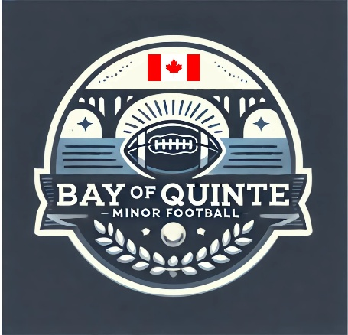

Section: Player Safety | Approval Date: February 12, 2026
Subsection: Rowan’s Law | Review Date: February 6, 2026
Policy Title: Concussion Policy & Protocol | Creation Date: July 17, 2025
Pertains To: Anyone coaching, playing, parenting at a BQMF game, event, or practice

Concussion Policy & Protocol
Bay of Quinte Minor Football (BQMF)
(Rowan’s Law Compliant)
1. Purpose
Bay of Quinte Minor Football (BQMF) is committed to the health, safety, and well-being of all participants. This Concussion Policy establishes clear procedures for the recognition, management, and return-to-play of athletes who may sustain a concussion during BQMF-sanctioned activities.
This policy complies with Rowan’s Law (Concussion Safety), 2018, and follows the Football Ontario Concussion Protocol, which is based on current medical evidence and national best practices
Football-Ontario-Concussion-Protocol (2017)
.

2. Scope
This policy applies to all players, coaches, officials, parents/guardians, league representatives, and volunteers participating in or attending any BQMF game, practice, or league event.

3. Education & Awareness (Pre-Season Requirements)
To support concussion prevention and early identification:
- All players and parents/guardians must review Rowan’s Law Concussion Awareness Resources annually and acknowledge completion prior to registration.
- All coaches and league officials must complete required concussion education, including:
  - Football Canada Making Headway in Football
  - Football Canada Safe Contact training (as applicable)
- Education will include:
  - What a concussion is
  - Signs and symptoms
  - Injury prevention strategies
  - What to do when a concussion is suspected
  - Return-to-School and Return-to-Sport requirements
  - Medical clearance requirements
Football-Ontario-Concussion-Protocol (2017)

4. Recognition of a Suspected Concussion
A concussion must be suspected and treated seriously when an athlete:
- Sustains a significant impact to the head, face, neck, or body and
- Shows any visible signs or reports any symptoms of concussion
All BQMF stakeholders—including players, coaches, officials, parents, and volunteers—share responsibility for recognizing and reporting suspected concussions
Football-Ontario-Concussion-Protocol (2017)
.
Red Flag Symptoms
If an athlete displays red flag symptoms (e.g., loss of consciousness, worsening headache, repeated vomiting, neck pain, seizures), emergency medical services must be contacted immediately.

5. Immediate Removal From Play
- Any athlete suspected of having a concussion must be immediately removed from play.
- No athlete with a suspected concussion may return to play on the same day, regardless of symptom improvement.
This rule is mandatory and non-negotiable.

6. Medical Assessment
- Athletes with a suspected concussion must undergo medical assessment by a Medical Doctor or Nurse Practitioner.
- The medical professional will determine whether:
  - A concussion has been diagnosed, or
  - A concussion has not been diagnosed
- The athlete (or parent/guardian) must provide the team with the appropriate Medical Assessment Letter
Football-Ontario-Concussion-Protocol (2017)

7. Concussion Management
If a concussion is diagnosed:
- The athlete must not participate in any activity with risk of head impact until medically cleared.
- The athlete must follow a graduated Return-to-School (Return-to-Learn) strategy before full sport participation.
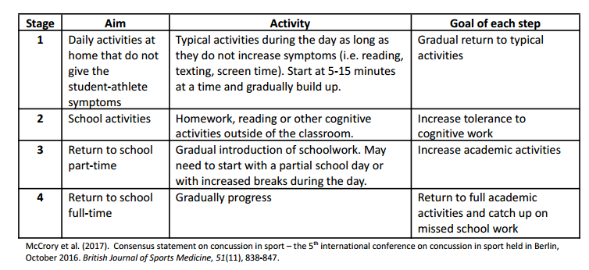

- The athlete must complete the Football-Specific Return-to-Sport Strategy, progressing through each stage without symptom recurrence

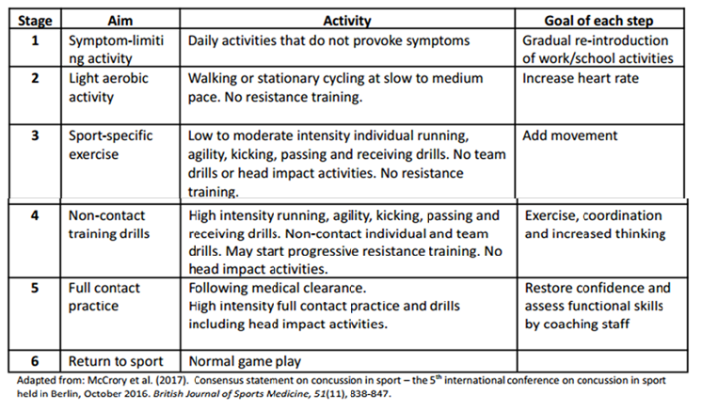
Football-Ontario-Concussion-Protocol (2017)

- Progression must be supervised by a medical professional.

8. Return to Sport
- Written Medical Clearance from a Medical Doctor or Nurse Practitioner is required before:
  - Full-contact practice
  - Game play
- Coaches must not allow an athlete to return without official medical clearance.
- If symptoms return at any stage, the athlete must stop activity and return to the previous stage or seek further medical assessment.

9. Roles & Responsibilities
Players
- Report symptoms honestly and immediately
- Follow all medical and return-to-play instructions
Parents/Guardians
- Monitor symptoms
- Ensure medical assessments are completed
- Provide required medical documentation
Coaches
- Remove athletes immediately when a concussion is suspected
- Enforce return-to-play restrictions
- Maintain documentation
- Never pressure an athlete to return early
League Commissioner
- Ensure enforcement of this policy
- Support coaches and families
- Address any violations of protocol
Failure to follow concussion protocols may result in disciplinary action under BQMF conduct policies.

10. Policy Enforcement
This policy is mandatory.
Any attempt to bypass, ignore, or override concussion protocols—including pressure to return early—will be treated as a serious safety violation and addressed by the League Commissioner and, if required, the Integrity Commission.

11. Review & Updates
This policy will be reviewed annually or as required to align with:
- Rowan’s Law updates
- Football Ontario / Football Canada guidance
- Emerging medical best practices

Acknowledgement
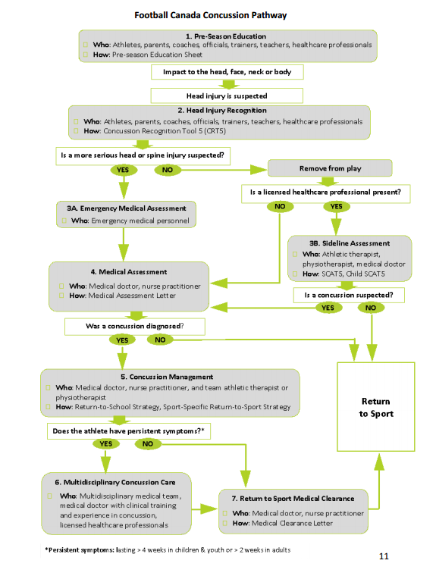
Participation in Bay of Quinte Minor Football confirms acknowledgement and acceptance of this Concussion Policy and Protocol.

