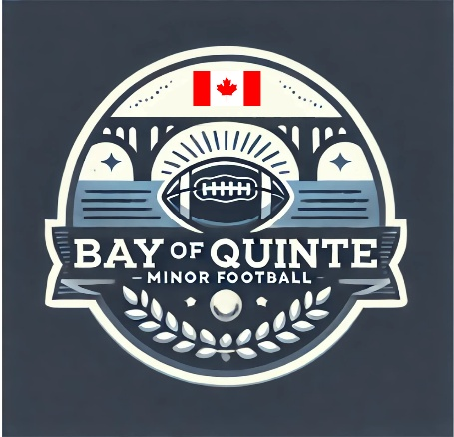

Section: Code of Conduct | Approval Date: February 12, 2026
Subsection: Conduct Violation | Review Date: February 6, 2026
Policy Title: Conduct Violation Management | Creation Date: July 17, 2025
Pertains To: All players, coaches, and league representative – parents/spectators are covered under a separate policy

Conduct and Discipline Policy
Bay of Quinte Minor Football (BQMF)
All persons involved with Bay of Quinte Minor Football (BQMF) are expected to conduct themselves with the highest degree of courtesy, integrity, and respect. It is BQMF policy that all players, coaches, league representatives, and volunteers involved in any BQMF game, event, or practice maintain a sportsmanlike and educational atmosphere before, during, and after all BQMF-sanctioned activities.

As responsibility for disciplinary action may vary depending on the setting and individuals involved, this policy addresses conduct expectations and procedures for practices, games, and league events. Regardless of the situation, the following behaviours are considered inappropriate and disruptive, including but not limited to:
a) Use of profanity, racist slurs, homophobic slurs, or other insults directed at another person.
b) Taunting or bullying through baiting, ridiculing, threats of physical violence, or actual physical violence.
c) Deliberate unsafe play intended to injure, and/or drills or activities that do not adhere to established safe-contact protocols.

Practices
Player Conduct
Any conduct violations by players during practices will be addressed by the team’s Head Coach. The Head Coach may consult with the League Commissioner when appropriate. Disciplinary actions may range from a verbal discussion to removal from the team in cases of repeated violations or significant incidents.
Spectator Conduct
Any conduct violations by spectators during practices will be documented by the Head Coach and may be addressed immediately when appropriate. For repeat violations or serious incidents, an incident report will be submitted to the League Commissioner. Refer to the Spectator Code of Conduct for additional information.
Coach Conduct
Any conduct violations involving a member of the coaching staff must be reported to the League Commissioner for follow-up. The League Commissioner will determine whether disciplinary action is warranted, up to and including removal of the coach. In cases where removal is being considered, the League Commissioner will engage the BQMF Integrity Commission to review the matter and provide a recommended course of action.

Games and League Events
Conduct violations during games or league events may be witnessed by game officials, players, coaches, or league representatives. As a result, no single individual is solely responsible for addressing all incidents. The following procedures will apply:
- Violations occurring on a team’s bench that are team-specific will be addressed by the Head Coach in the same manner as practice-related violations.

- If a player receives an Unsportsmanlike Conduct penalty related to Sections (a) or (b) above, or receives two Unnecessary Roughness penalties during gameplay, an automatic review will be initiated by the League Commissioner in collaboration with the Head Coach.
  - First offence: Player should be removed from play, coached and corrected, and may return to play after a minimum of (1) play on the field.
  - Second offence: Player is removed for the remainder of the game and my have a one-game suspension
  - Recurring Offence: suspension for the remainder of the season

- If, during a game or event, an opposing coach or player identifies a player or coach from the opposing team violating Sections (a) or (b), the incident should be reported via email to the League Commissioner with relevant details. A review will be initiated in collaboration with the Head Coach(es).
  - First offence: one-game suspension
  - Second offence: suspension for the remainder of the season

- If, during the review of game footage, any member of BQMF identifies a player violating Section (c) that was not penalized during the game and appears to warrant further review, the individual must document the timestamp and nature of the incident and submit it to the League Commissioner. The League Commissioner will determine whether follow-up action is required based on the review.

Discipline Dispute Process
If a player, coach, or parent/guardian disagrees with a disciplinary action imposed by a Head Coach, game officials, or the League Commissioner, they may request a meeting with the League Commissioner to provide additional information that may not have been considered during the initial review.
If the individual remains unsatisfied following this discussion, they may request that the matter be formally reviewed by the BQMF Integrity Commission, whose decision will be considered final.

