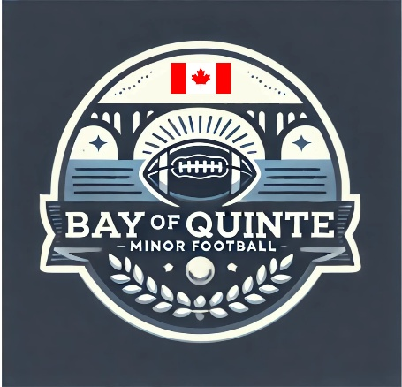

Section: Code of Conduct | Approval Date: February 12, 2026
Subsection: Spectators | Review Date: February 6, 2026
Policy Title: Spectators Code of Conduct | Creation Date: July 17, 2025
Pertains To: Anyone Attending a BQMF Game,
Event, or Practice

It is Bay of Quinte Minor Football (BQMF) policy to require any person attending a BQMF game, event, or practice to maintain a sportsmanlike and educational atmosphere before, during, and after all BQMF-sanctioned activities. On-field officials, league representatives, or the League Commissioner have the authority to stop a game or practice when spectators display inappropriate or disruptive behaviour that interferes with other spectators or the conduct of the game or practice. Violators will be identified to the League Commissioner and/or coaches for the purpose of removing parents or spectators from the designated viewing area. PERMIT HOLDERS MAY ENFORCE TRESPASSING (with Police if necessary). Once the individuals are removed, play will resume. Lost time will not be replaced, and violators may be subject to further disciplinary action by the BQMF League Commissioner.

Inappropriate and disruptive behaviour includes, but is not limited to:

- Use of obscene or vulgar language in a boisterous manner toward anyone at any time.
- Taunting of players, coaches, officials, or other spectators by means of baiting, ridiculing, threats of physical violence, or actual physical violence.
- Throwing any object in the spectator viewing area, playing area, or field in a manner that creates a disruption or safety hazard.

Spectators involved in a BQMF event are expected to conduct themselves with the highest degree of courtesy, integrity, and respect. Parents and spectators are required to remain in designated spectator areas. Furthermore, parents and spectators are to avoid any contact with the players’ bench or the official timekeepers’ area during games unless specifically requested by a member of the coaching staff. At no time are spectators permitted to have direct contact with referees before, during, or after a game.

In the event of disorderly conduct, the League Commissioner or League Representative is responsible for ordering spectators to leave the premises (Police can be called if necessary). Following the game, practice, or event, coaches and/or the League Commissioner will collect statements from witnesses, document the incident, and file a written incident report with Bay of Quinte Minor Football (BQMF).

First Offence
The League Commissioner will review the incident and make recommendations based on the following guidelines:
- For profanity or other verbal abuse, a minimum one-game suspension will be applied.
- For physical abuse, a minimum season-long suspension will be considered.

Second Offence
The BQMF Integrity Commission will conduct an investigation that may result in a longer suspension. For the most serious violations, the laying of charges will be considered. Profanity, verbal abuse, or physical abuse includes any behaviour directed at players, coaches, officials, or other spectators.

