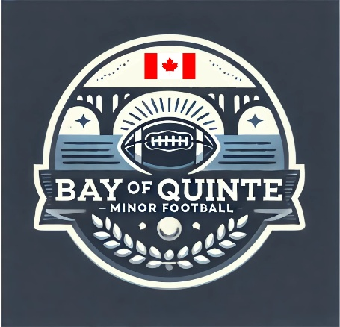

Section: Code of Conduct | Approval Date: February 12, 2026
Subsection: Coaches | Review Date: February 6, 2026
Policy Title: Coach Code of Conduct | Creation Date: July 17, 2025
Pertains To: Any Coach Associated with a Team

Coach Code of Conduct

Bay of Quinte Minor Football (BQMF)

Coaches play a critical role in setting an example for young athletes and in representing Bay of Quinte Minor Football. As such, coaches are expected to:
- Remember that a child does not care how much you know until they know how much you care.
- Be a positive role model for all players.
- Understand that while winning is a consideration, it is not the most important one. Care more about the child than the outcome of the game. Players participate in minor football to have fun and to learn the game.
- Display emotional maturity at all times.
- Be alert to and prioritize the physical safety of all players.
- Be generous with praise when it is deserved.
- Be fair and just and never criticize players publicly.
- Teach and model good sportsmanship and respect for parents, opponents, and officials.
- Be patient, understanding, and upbeat, and encourage an atmosphere of fun.
- Familiarize yourself with the rules, techniques, and strategies of football.
- Communicate effectively; do not rely on yelling at players or officials.
- Recognize your influence on players and act with honesty and consistency.
- Teach the importance and value of teamwork.
- Emphasize the development of fundamental football skills.
- Be attentive and adaptable to the personal needs and challenges of players.
- Maintain open lines of communication with players’ parents and guardians, and clearly explain the goals and objectives of Bay of Quinte Minor Football.
- Never verbally or physically abuse a player, official, or volunteer.
- Provide all players with opportunities to improve their skills, gain confidence, and develop self-esteem.
- Organize practices that are both fun and appropriately challenging.
- Be concerned with the overall development of players, including promoting good health habits and positive lifestyle choices.
- Never use profanity, racist, homophobic, or other inappropriate language around players, parents, officials, or volunteers.

