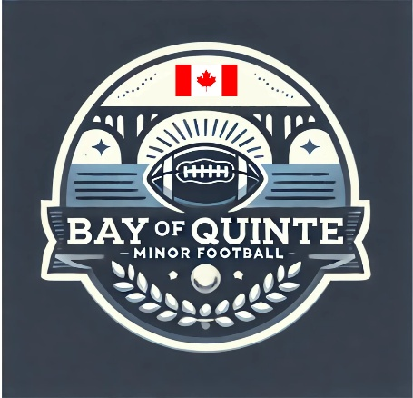

Section: Roles and Responsibilities | Approval Date: February 12, 2026
Subsection: Commissioner | Review Date: February 6, 2026
Policy Title: Commissioner Roles and Responsibilities | Creation Date: July 23, 2025
Pertains To: League Commissioner

League Commissioner Policy
Bay of Quinte Minor Football (BQMF)

The BQMF League Commissioner is responsible for the overall governance, management, and integrity of Bay of Quinte Minor Football. This role encompasses administrative oversight, rule enforcement, public relations, and strategic growth initiatives that support the long-term success and sustainability of the league.

While the League Commissioner retains overall responsibility for all duties outlined in this policy, certain tasks may be delegated to league representatives as appropriate to ensure effective league operations.

Core Roles and Responsibilities of the League Commissioner
League Governance and Administration
- Setting and enforcing rules: Establishing, communicating, and upholding league rules and policies related to gameplay, conduct, safety, and player eligibility.
- Managing league operations: Overseeing scheduling, team and player placement, standings, and playoff formats.
- Financial oversight: Managing league fees, budgets, expenditures, and revenue streams in a responsible and transparent manner.
- Communication: Maintaining clear, timely, and consistent communication with teams, coaches, players, parents/guardians, volunteers, and other stakeholders.
Discipline and Integrity
- Enforcing disciplinary actions: Addressing violations of league policies and codes of conduct in a fair and consistent manner.
- Ensuring fair play: Safeguarding the integrity of the game and ensuring league standards are upheld on and off the field.
- Conflict resolution: Mediating disputes and serving as the final decision-maker on issues that arise within the league.
Strategic Development and Public Relations
- Public representation: Acting as the public face of Bay of Quinte Minor Football and engaging with media, community partners, and the public.
- Growth and sustainability: Identifying and implementing initiatives to grow participation, strengthen programs, and ensure the long-term viability of the league.
- External relations: Liaising with external partners such as sponsors, governing bodies, and service providers.
- Sponsor recognition: Ensuring league sponsor signage is properly displayed at all games and league events.
Game-Specific Responsibilities
- Supervising game operations: Ensuring games run smoothly, safely, and in accordance with league schedules and regulations.
- Facility management: Coordinating with venue managers to ensure facilities are suitable for play, fields are properly booked and lined (excluding Mary Ann Sills Turf where applicable), and equipment is returned to designated storage areas following games.
- Team and official coordination: Verifying team readiness and ensuring referees and timekeepers are scheduled and present for all games.
- Incident reporting: Documenting and reporting any incidents, disputes, or disciplinary matters that occur during games or league events.
- Game recording: Overseeing the setup and takedown of league cameras during games and ensuring game footage is posted following the conclusion of each game.
- Awards coordination: Ensuring Player of the Game and year-end awards are purchased and available for all teams.
Developing Coaches and Supporting Teams
- The League Commissioner shall not serve as a Head Coach of a team.
- The Commissioner may assist with new teams or teams with fewer than three adult (18+) coaches, including mentoring new Head Coaches when needed.
- Providing guidance, information, and mentorship to coaches on team operations, including equipment, uniforms, parent communication, and team management.
- Ensuring that at least one coach on every team holds NCCP Level 1 certification.

