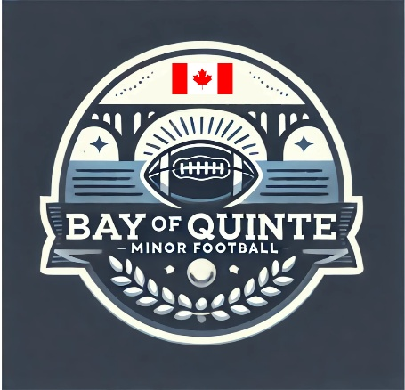

Section: Code of Conduct | Approval Date: February 12, 2026
Subsection: Parents | Review Date: February 6, 2026
Policy Title: Parent Code of Conduct | Creation Date: July 17, 2025
Pertains To: Parents or Guardians of Players

Parent / Guardian Code of Conduct
Bay of Quinte Minor Football (BQMF)

Parents and/or guardians play a key role in setting an example for young athletes and, as such, are expected to:

- Encourage participation in sport, but do not force an unwilling child to participate.
- Remember that children participate in organized sports for their enjoyment—not yours.
- Insist that your child always plays by the rules.
- Recognize the importance of practice in developing your child’s football skills.
- Never determine your child’s worth by whether the team wins or loses. Teach that honest effort is as important as victory, and help your child accept outcomes without undue disappointment.
- Be positive and encouraging. Turn defeat into growth by helping your child focus on skill improvement and good sportsmanship. Never yell at your child for making a mistake.
- Remember that children learn best by example. Applaud good plays by your team and by opposing players.
- Do not publicly question an official’s judgment, and never question their honesty.
- Support all efforts to eliminate verbal and physical abuse from children’s sporting activities.
- Recognize and respect the value of volunteer coaches, who give their time and resources to provide positive experiences for your child.
- Do not discuss other teams’ players in terms of ability or aptitude in front of your child.
- If you have concerns regarding your child, be considerate of the coach and choose an appropriate time to discuss them. Immediately after a game is generally not an appropriate time.

